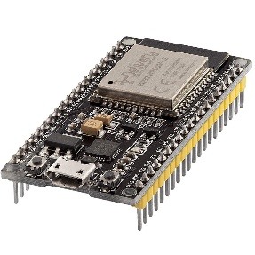 | COMPUTER SCIENCE DEPARTMENT  TC1004B – INTERNET OF THINGS IMPLEMENTATION  ACTIVITY 1 – Processes
 | Name: _________________________  ID: _________________________ | Name: _________________________  ID: _________________________

Instructions:

Section 1: Vector addition with processes

- Write a program that adds two vectors. Receive the dimension N from the command line. Launch a process that calculates each element of the resulting vector. Test with N = 10.

- Fill out the following:

Listing 1.1. Commented code

Short description (no more than 10 lines) of the implemented algorithm on a yellow square.

Listing 1.2. System/Program description

Listing 1.3. Screenshot/picture of the working system/program

